Name:Akanksha Songire

Roll No:BCOD22

**Cloud Computing MiniProject**

**Problem Statement**:: Setup your own cloud for Software as a Service (SaaS) over the existing LAN in your laboratory. In this assignment you have to write your own code for a cloud controller using open source technologies without HDFS. Implementing the basic operations may be like uploading and downloading files on/from the cloud in encrypted form.

**Solution:**

Step 1:Update Ubuntu System Packages

Command:sudo apt update -y && sudo apt upgrade -y

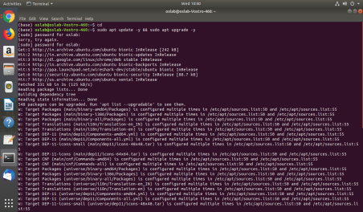

Step 2:Install Apache and PHP 7.2 in Ubuntu

Command:sudo apt install apache2 libapache2-mod-php7.2 openssl php-imagick php7.2-common php7.2-curl php7.2-gd php7.2-imap php7.2-intl php7.2-json php7.2-ldap php7.2-mbstring php7.2-mysql php7.2-pgsql php-smbclient php-ssh2 php7.2-sqlite3 php7.2-xml php7.2-zip

Step 3:Verify whether Apache2 have be installed and then start and enable the Apache2 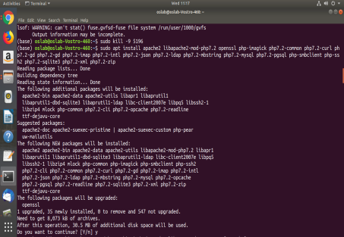

Commands:sudo dpkg -l apache2(verify)

sudo systemctl start apache2(start)

sudo systemctl enable apache2(enable)

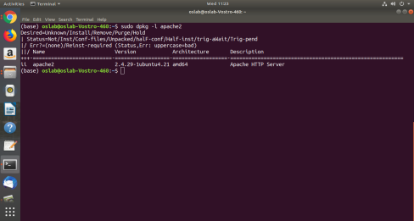

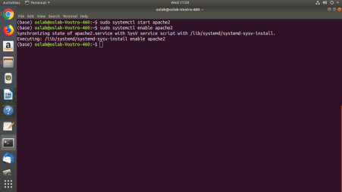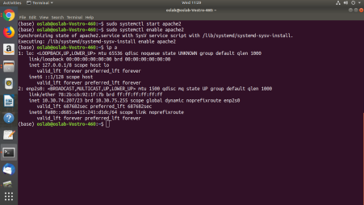After typing the server IP address of your computer we get the Apache page

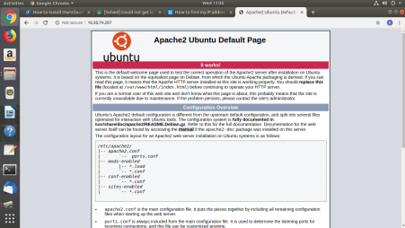Check if Php is installed

Command: php -v

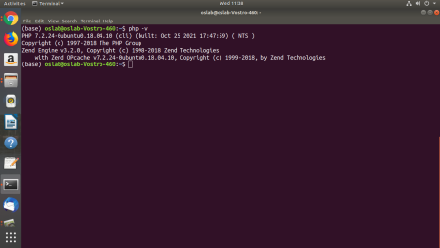

Step 4:Install Maria DB in Ubuntu

Command:sudo apt install mariadb-server

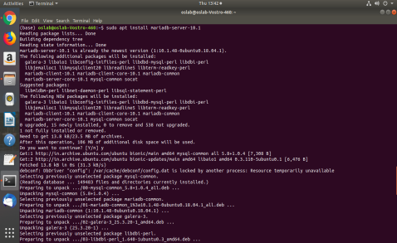

Step 5:Create an Owncloud Database

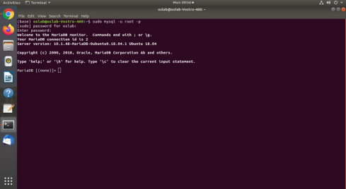Step 6: Download OwnCloud in Ubuntu

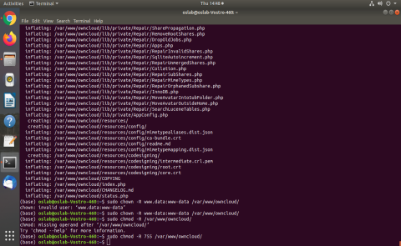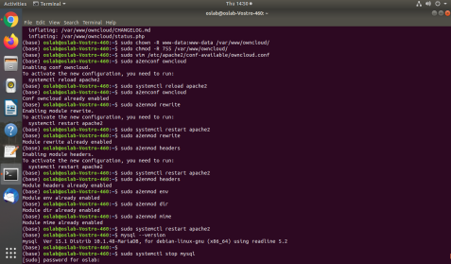

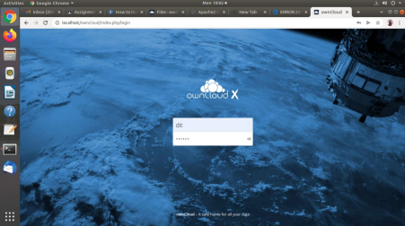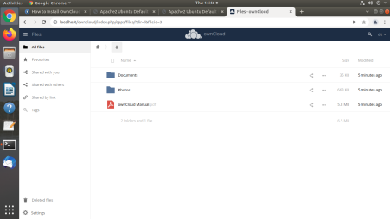Conclusion:Hence we have successfully installed and configured OwnCloud.

**MODULE 2(Create Multiple Users)**

Step 1.Login to owncloud as an administrator.



Step 2.Click the icon in the right-top corner and the select ‘Users’ from the drop down list.

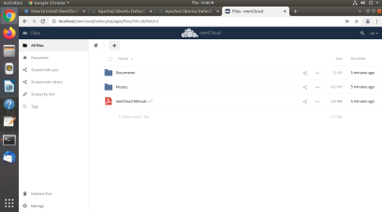

Step 3.After selecting it , to create a new user enter username and email in the textbox. After that password can be set to the created user.

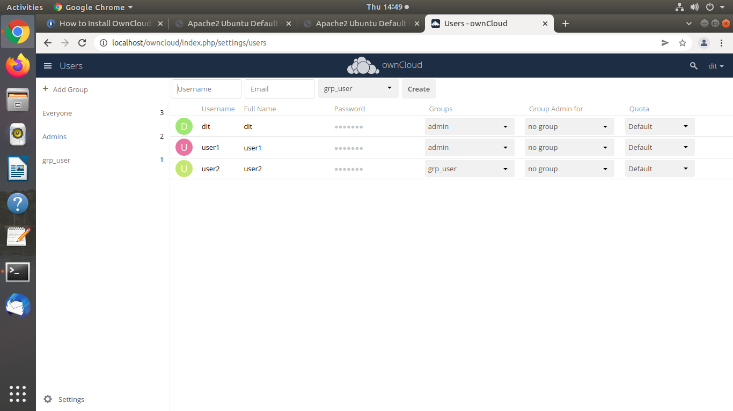

Step 4.The newly created user can be added in the same group or a new group can be created by clicking the ‘Groups’ button.

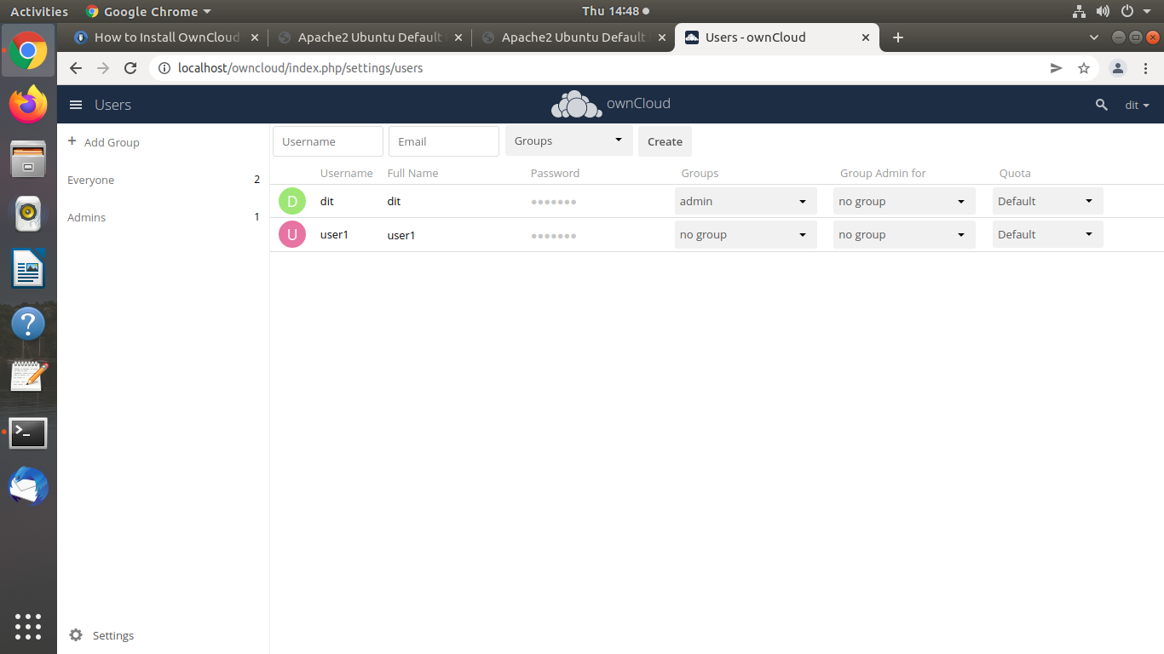

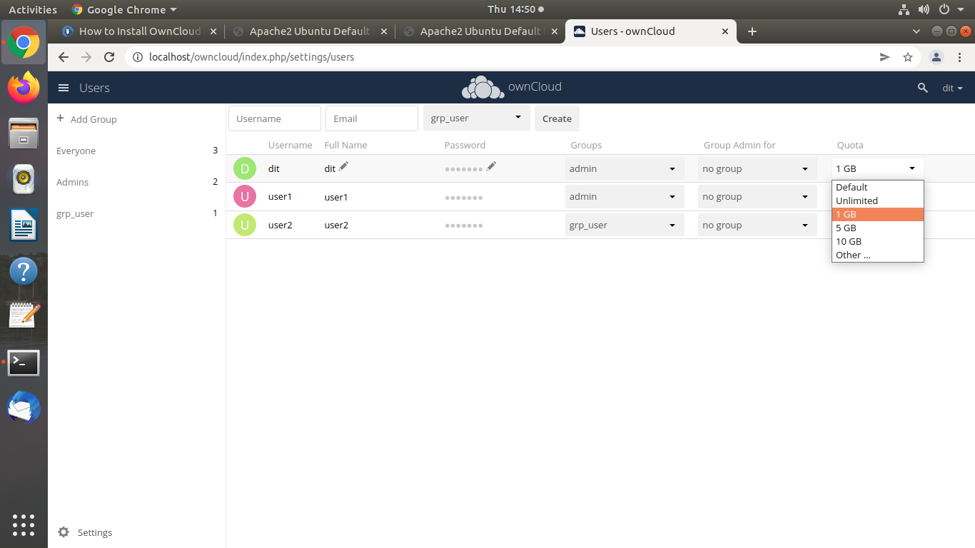

**Module 3(Upload and Download)**

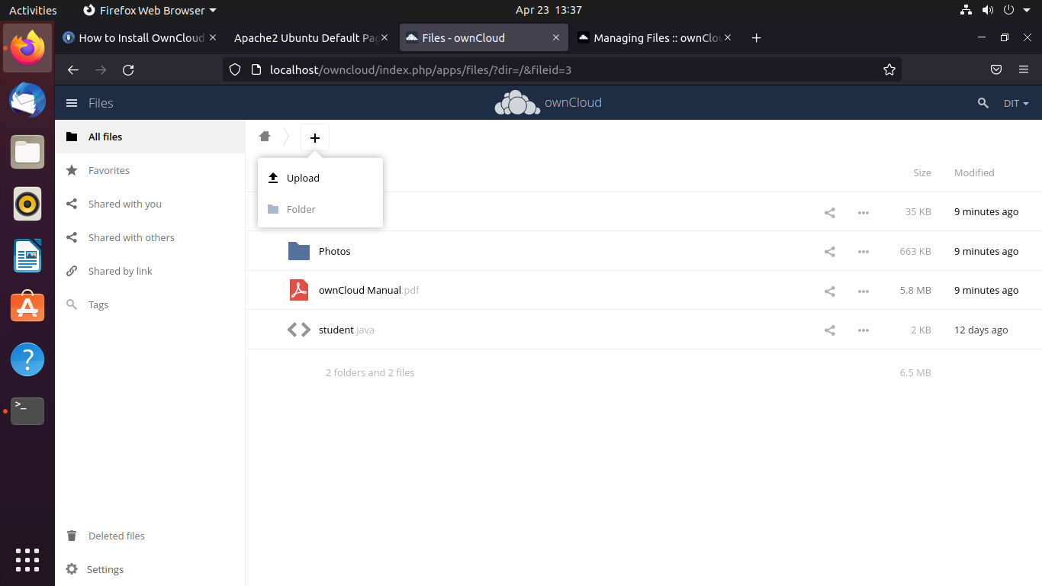

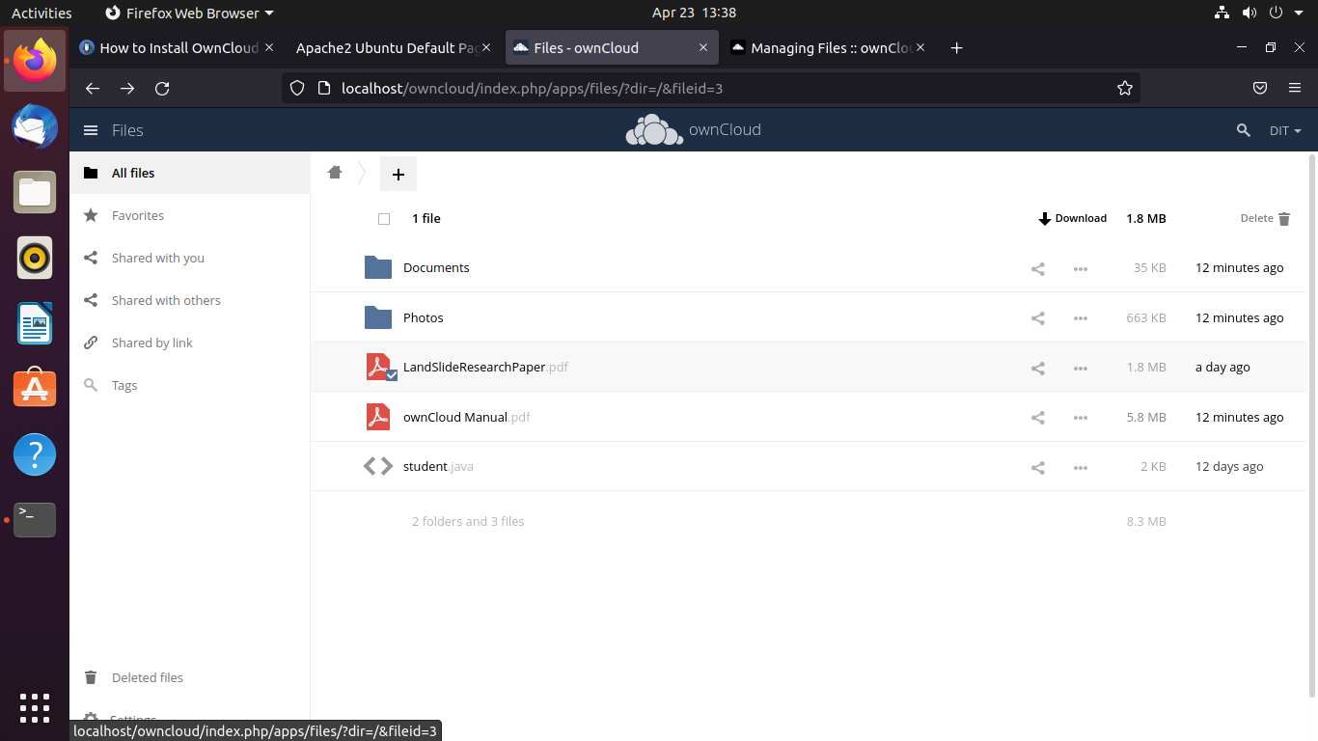

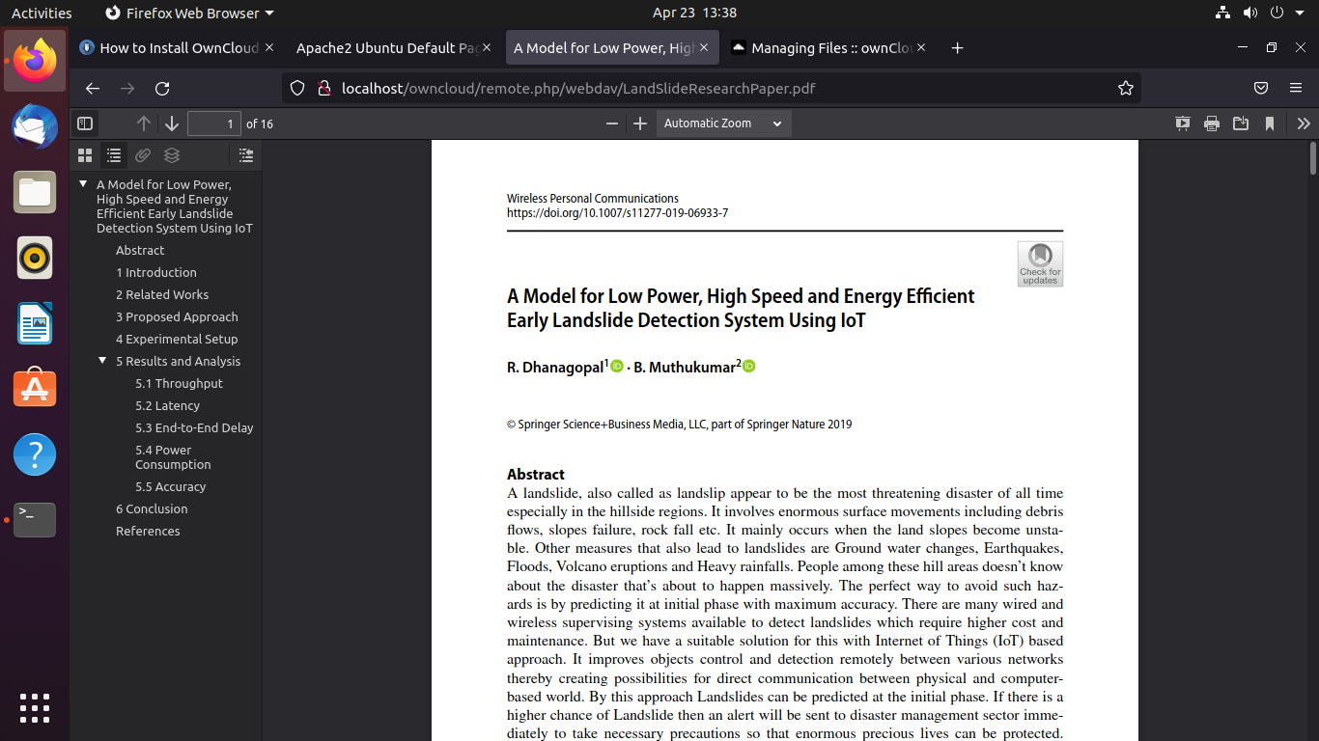

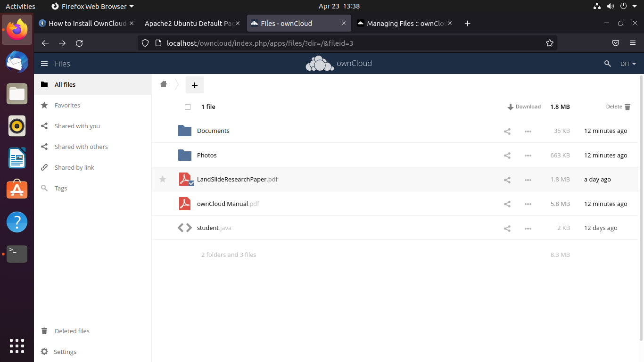

**Conclusion:**We have Successfully Created, Managed and grouped User accounts in own Cloud by Installing Administrative Features.And uploaded and downloaded a file in own_cloud using HDFS.